Network Diagram and GitHub Workflow
3.1. Network Diagram Description
The network diagram illustrates how team members connect to the GitHub repository via the Internet. Each member uses a personal computer (PC or laptop) connected to a router within their home network. The router provides Internet access through an Internet Service Provider (ISP). Through this connection, users can access cloud services such as GitHub, where project files are stored and managed. This system enables multiple users to collaborate remotely in an efficient manner.

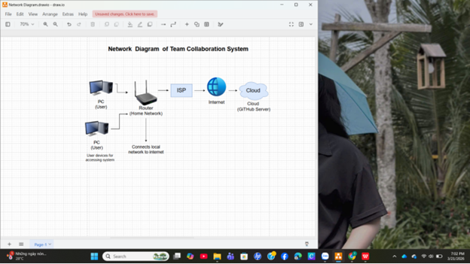
3.2. GitHub Workflow
The team uses GitHub as a cloud-based platform to store and manage the project. First, a repository is created by Member 3. Then, other members are added as collaborators. Each member uploads their work by creating or editing files and committing changes to the repository. Each person is required to make at least three commits to ensure active participation. GitHub keeps track of all changes, helping with version control and preventing data loss. This workflow ensures the team works efficiently and stays organized.
Repository link:
https://github.com/tranthingochuyen248-ops/GroupProject
3.3 Role of the Infrastructure & GitHub Specialist
The Infrastructure & GitHub Specialist is responsible for creating the repository, managing access permissions, and guiding team members on how to use GitHub. Additionally, this person designs the network diagram and verifies that GitHub links are working properly. This role helps ensure the team’s workflow runs smoothly and that the project is completed according to requirements.

